Tugas Test Management Tools

Implementasikan Test Case Management Tools untuk Rest Api Todoist.com

1. Membuat project

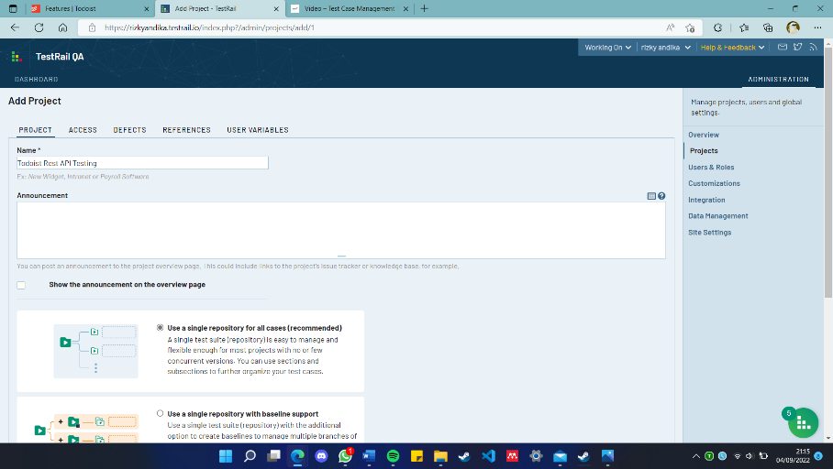

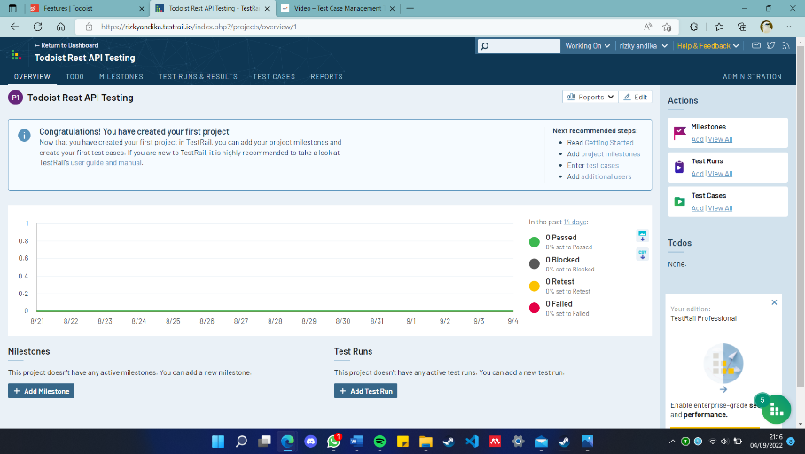

1. Membuat milestone

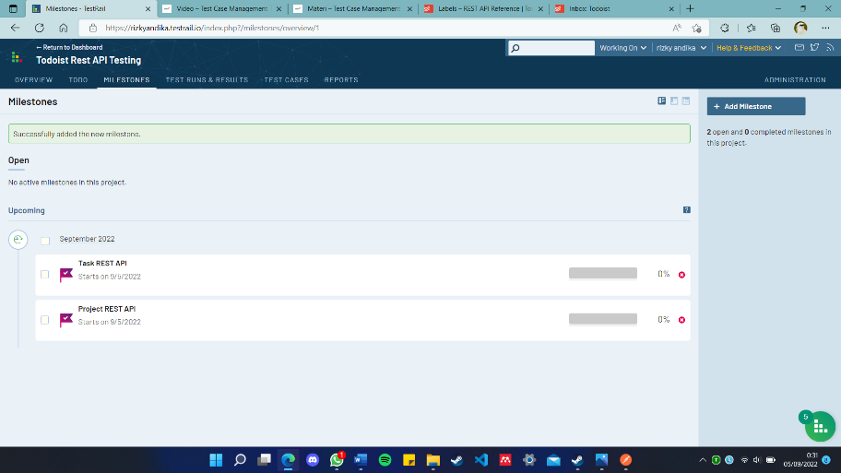

1. Membuat test case

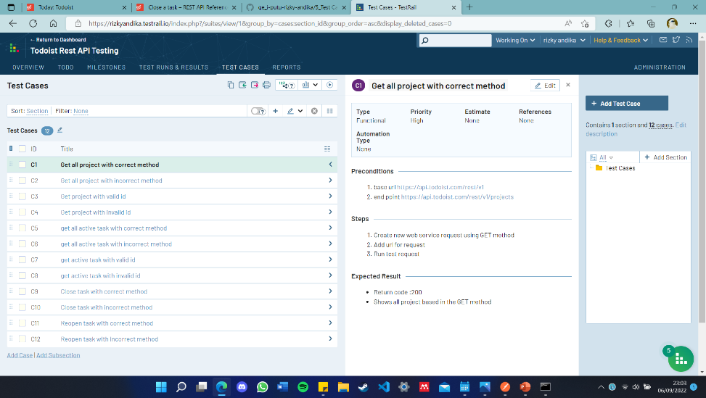

1. Menguji test case

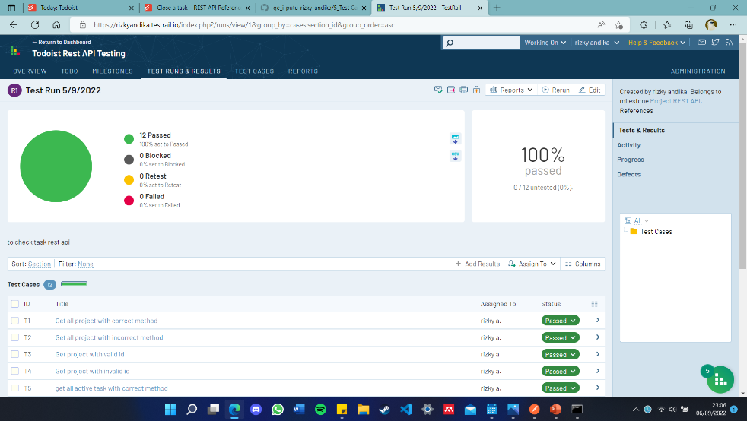

1. Positif case get all project with correct method

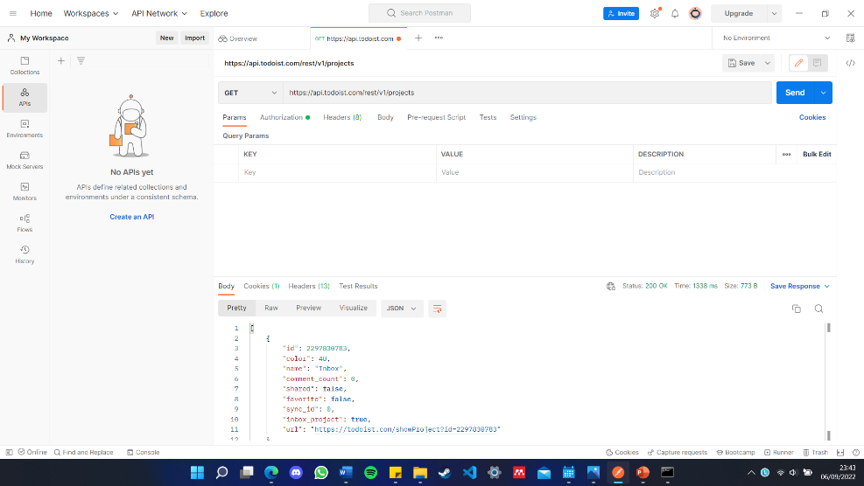

1. Negatif case get all project with incorrect method

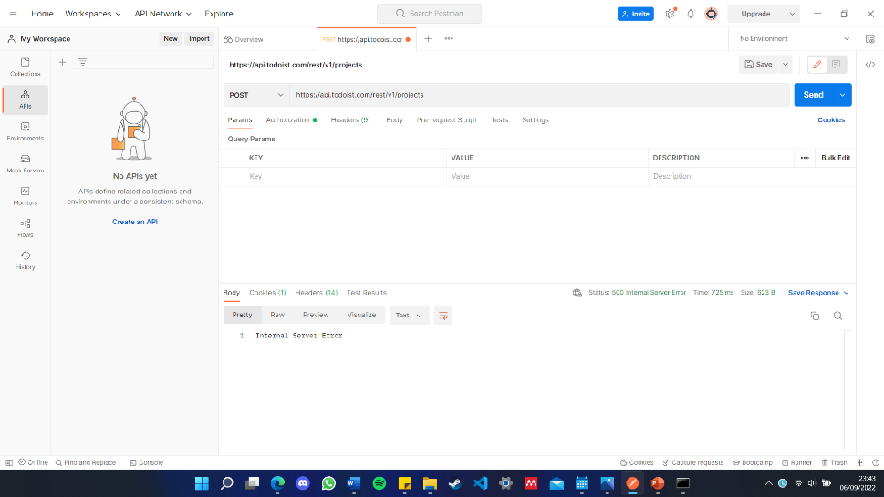

1. Positif case get all task with correct method

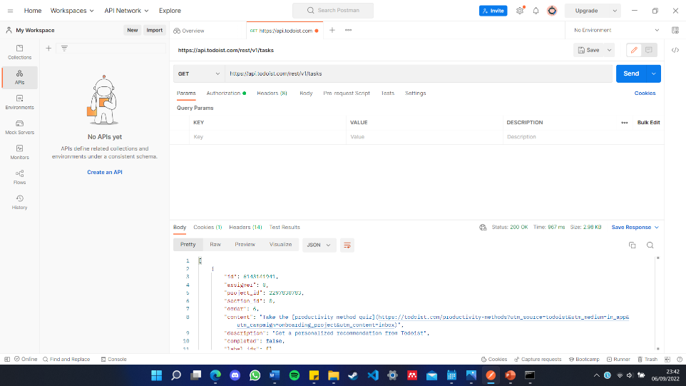

1. Negatif case get all task with incorrect method

